* 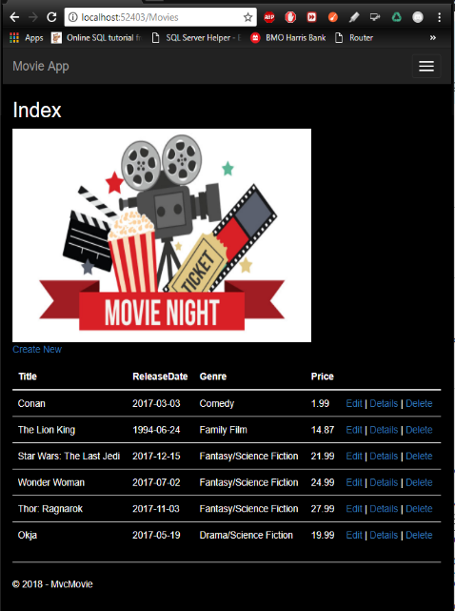**5 points (3 points/each) - Copy/Paste the results of your Movie application, showing your 6 movies. Show your index, create and details windows: (paste on last page also)**

1. **15 pts** – Paste the results from your page 7 requirements(6 initial movies listed)

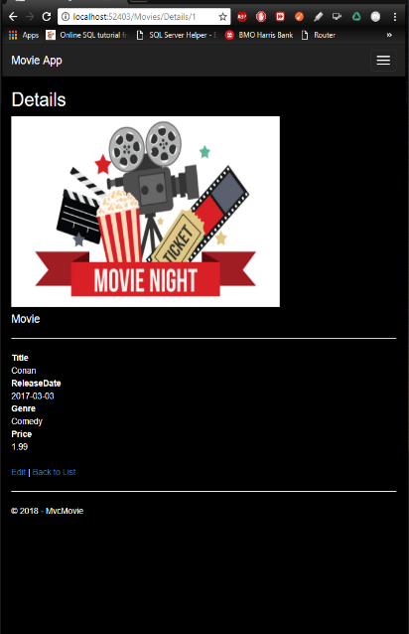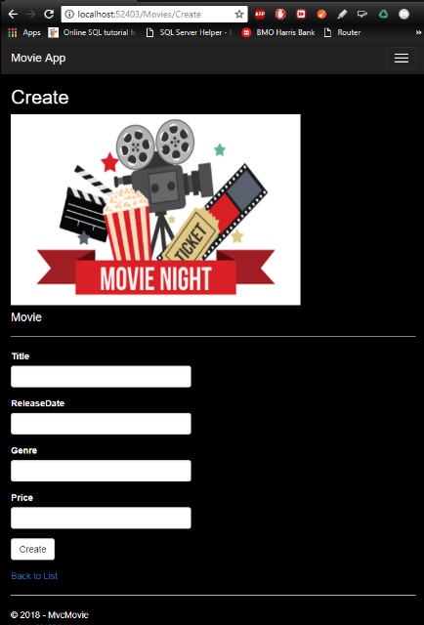

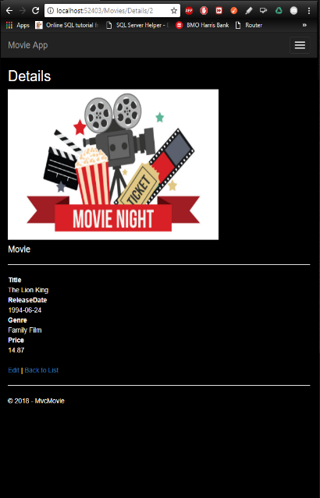

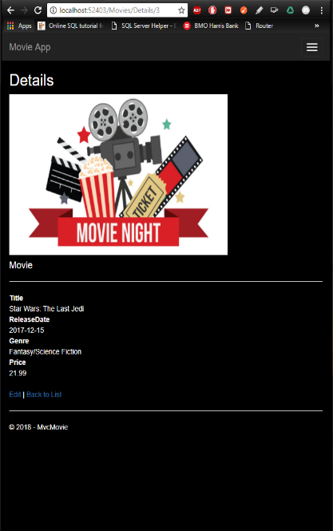



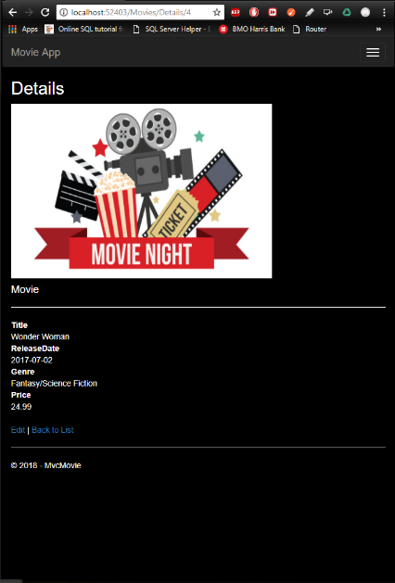

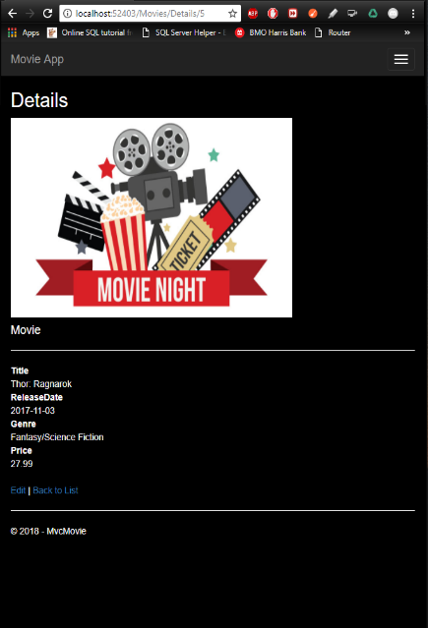





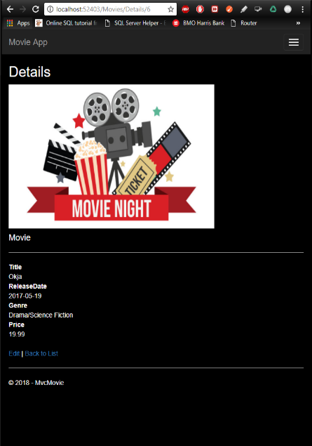

1. **5 pts** – Paste the results of running your application with the SeedData executing properly:
   * 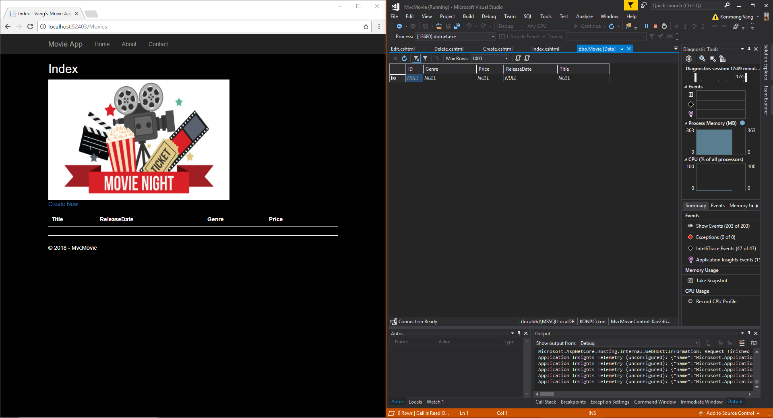Your results should show the same results as shown on the previous step
2. **5 pts** - Add again 5 movies of your own choice. Research the correct release dates. You previously added 5 movies when you completed the first tutorial (Adding a Model) – see page 7 of the original write-up. Make sure your Create, Edit, Details, Delete and Index links all work properly!
   * 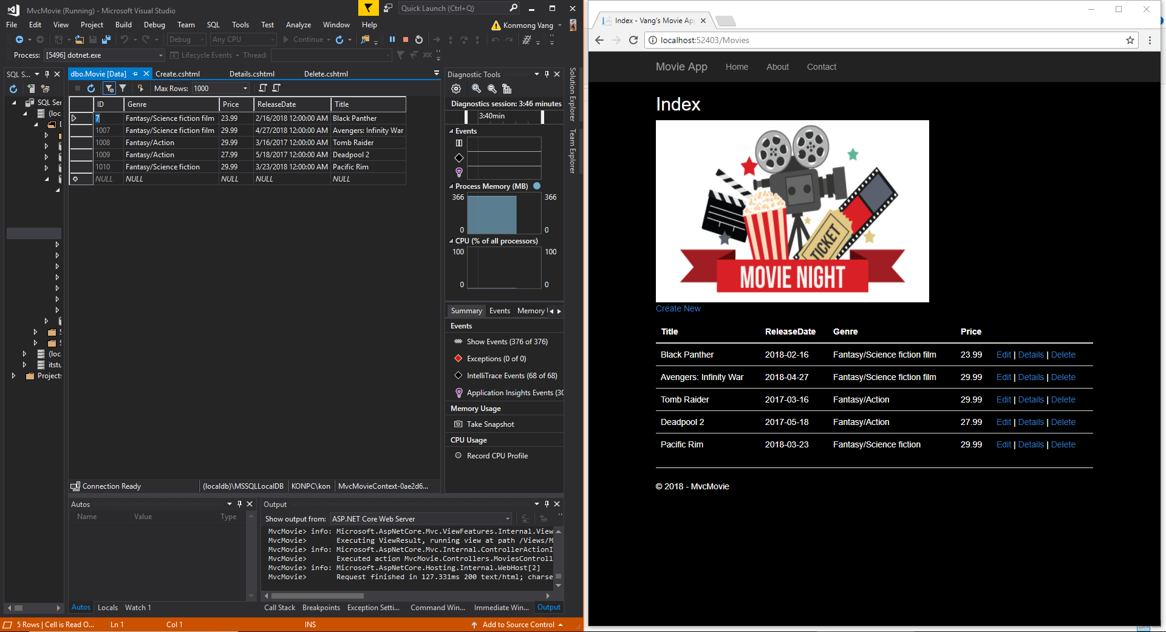Paste the results below showing your MvcMovie’s Index page, including the movies added from the SeedData method and your additional 5 movies:
3. 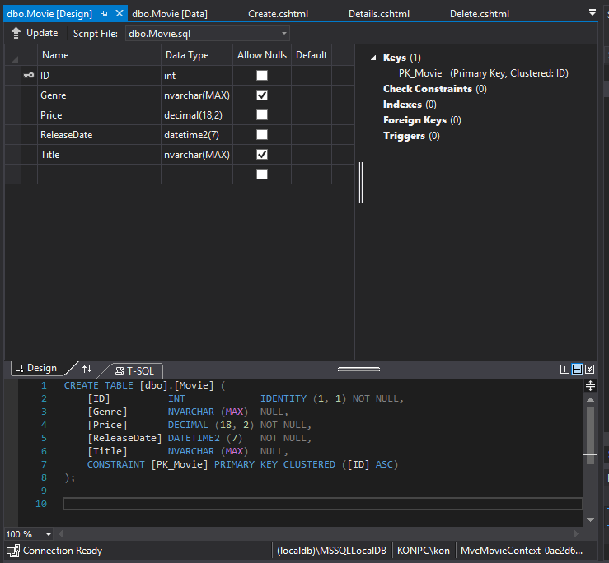**5 pts** - Paste the design of your database below (SQL Server Object view / View Designer):
4. 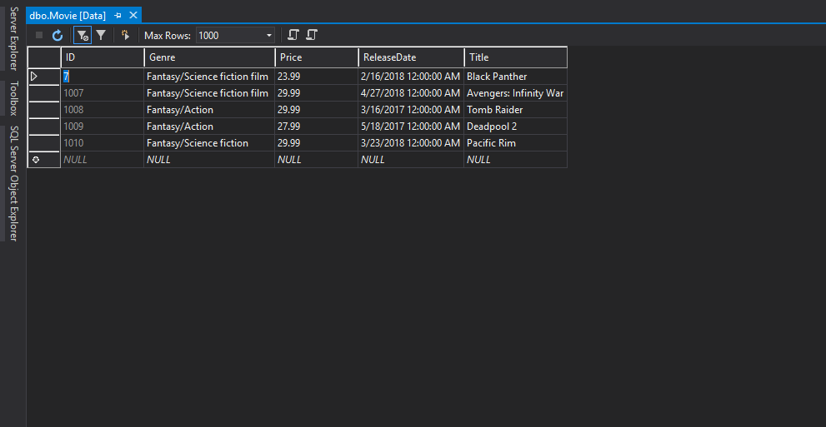**5 pts** - Paste the design of your database below (SQL Server Object view / View Data) displaying your actual database records: (You may need to refresh the database)
5. **5 pts** - Save All (Word & VS) / Submit only page 7 and page 12 (with your screen prints included), along with your zipped project.